Project Design Phase
Problem – Solution Fit Template

Date
Student ID | 23NU1A4221
Project Name | Metro Ticket Generating System in ServiceNow
Maximum Marks | 2 Marks

Problem – Solution Fit Template
The Problem-Solution Fit for the Metro Ticket Generating System focuses on identifying the difficulties faced by metro passengers during ticket booking and providing a digital solution that addresses these problems. The system simplifies ticket booking by allowing passengers to enter their source and destination, calculate the fare, select the required number and type of tickets, and receive a digital QR-based ticket through the Service Portal. By reducing manual effort, waiting time, and errors in fare calculation, the solution provides a convenient and efficient ticketing experience.
Purpose:
- Reduce passenger waiting time by providing a digital and streamlined ticket booking process.
- Simplify ticket booking by allowing passengers to enter journey details and generate tickets through the Service Portal.
- Minimize fare calculation errors through automated fare calculation based on source, destination, and passenger type.
- Reduce manual effort by automating ticket creation and processing using Business Rules and Flow Designer.
- Provide secure digital tickets through QR-code-based ticket generation for easier verification at metro stations.
- Improve passenger convenience by providing a simple, accessible, and user-friendly ticketing system.
- Understand existing ticketing difficulties and improve the overall passenger experience by addressing common problems such as long queues, manual errors, and inconvenience in obtaining tickets.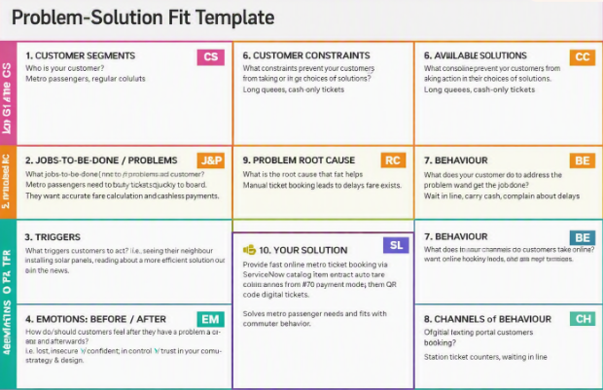
References:
- https://www.ideahackers.network/problem-solution-fit-canvas/
- https://medium.com/@epicantus/problem-solution-fit-canvas-aa3dd59cb4fe

